# ASSIGNMENT—2

|  |  |
| --- | --- |
| NAME | MARIA JEEVITHA.T |
| QUESTION | Build a python code, Assume you get temperature and humidity value  (generated with random function to a variable) and write a condition to continuously detect alarm in case of High Temperature. |

CODE:

import random

temp= random.randint(18,25) print("The Temperature is: ",temp) humid = random.randint(30,60)

print("The Humidity is: ",humid,"%") if temp>15:

print("High Temperature") if humid >25:

print("HIgh Humidity")

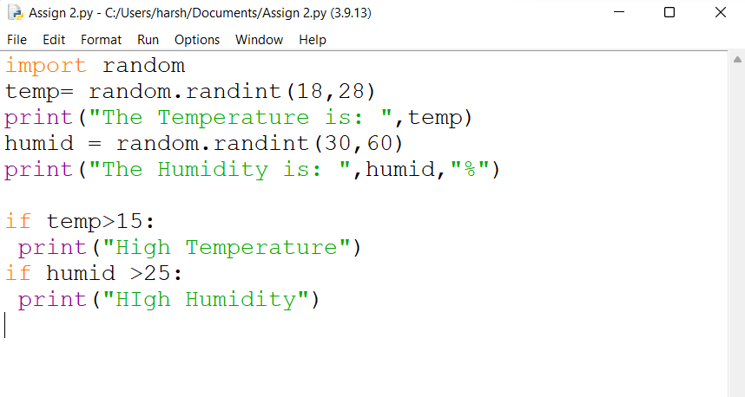



Python 3.9.13 (tags/v3.9.13:6de2ca5, May 17 2022, 16:36:42) [MSC i

929 64 bit (AMD64)I on win32

Type "help", "copyright", "credits" or for more inform ion.

== RESTART: C:/Users/harsh/Documents/Assign 2.py is: 23

is: 33 %

0Igh

== RESTART: C:/Users/harsh/Documents/Assign 2.py

Temperature is: 28

is: 54 % High Temperature

== RESTART: C:/Users/harsh/Documents/Assign 2.py The Temperature is: 19

The is: 58 % High Temperature